Hilton Oct BGT Storefront AB test result Update as of 2017-11-29:

Since the configuration ID’s reset on Nov 24th, five days passed for the storefront test during the baseline period. The Test Storefront is consistently generating higher Conversion and higher Revenue per Visitor than the Control Storefront. Hilton launched a BG Promo this morning; we will reset the configuration ID’s and restart the test to track performance in Promo. During the five days,

1. The Revenue per Visitor of the Test Storefront is **+1% higher** than that of the Control Group
2. The conversion rate of the Test Storefront is **+7% higher** than that of the Control Storefront
3. The ATS of the Test Storefront is **-6% lower** than that of the Control Storefront

You can find the report here,

<https://data.points.com/#/views/Hilton_Oct2017_StorefrontBaseline_ABTestafterreset/Story>

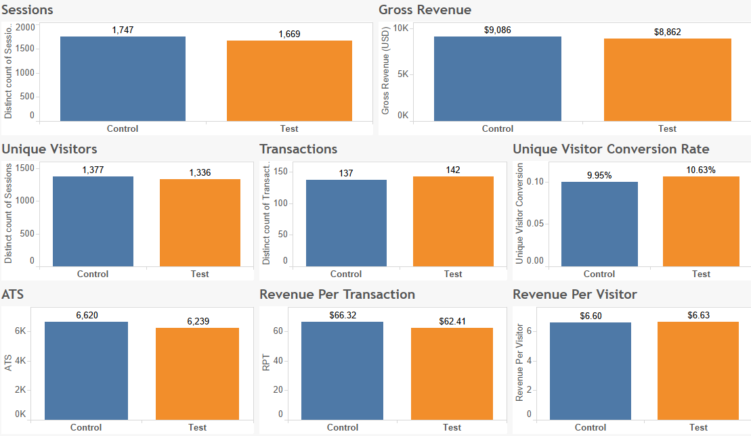

For the entire baseline period between Oct 6th and Nov 28th,

1. The Revenue per Visitor of the Test Storefront is **+8% higher** than that of the Control Storefront
2. The conversion rate of the Test Storefront is **+4% higher** than that of the Control Storefront
3. The ATS of the Test Storefront is **+3% higher** than that of the Control Storefront
4. **Neither ATS nor Conversion reached statistical significance**